INSIDE THE MIND OF A UNIVERSITY STUDENT

PRESENTED BY
MUHAMMMAD BILAL (2025-CS-288)
FASEEH HAIDER (2025-CS-269)
TAYYAB JABBAR (2025-CS-278)
SABAH UD DIN AHMAD (2025-CS-289)
SHURAHBEEL ABDUR REHMAN (2025-CS-258)



INSTRUCTOR : MS RAMSHA KHALID
SUBJECT : APPLICATION OF INFORMATION AND COMMUNICATION TECHNOLOGY
DATE : 08 /01/ 2026

DEPARTMENT OF COMPUTER SCIENCES
UNIVERSITY OF ENGINNERING AND TECHNOLOGY
LAHORE
Executive Summary
This website is designed as a centralized platform for understanding, hosting, and participating in hackathons. It provides clear informational content on what hackathons are, how they work, and why they are valuable learning experiences for students and technology enthusiasts. The platform displays details of the hackathon being hosted, including themes, schedules, costs, and participation modes, while also highlighting projects developed by previous participants to demonstrate real outcomes and impact. By combining educational guidance, structured event information, and project showcases, the site aims to make hackathons more accessible, transparent, and engaging for both participants and organizers, while supporting effective event management through well-structured backend data.

Table of Contents
Project Objectives 4
1. Awareness of Hackathons 4
2. Support for Pakistani Students and Engineers 4
3. Centralized Hackathon Platform 4
4. Project and Skill Showcase 4
5. Academic and Technical Learning 4
Project Scope 4
1. Target Audience 4
2. Platform Coverage 4
3. Hackathon Information Management 4
4. Project Showcase and Learning Support 5
5. User Experience and Accessibility 5
6. Educational Purpose 5
Site Structure and Navigation 5
Home Page 5
Hackathons 6
Themes 7
Projects 8
About Us 8
Contact Us page 9
How to Run the Site 11
Reflection 11

Project Objectives
The main objectives of this project are as follows:

Awareness of Hackathons
  - To provide clear and structured information about hackathons and their importance in technical learning.
  - To explain how hackathons work, including themes, schedules, and participation formats.

Support for Pakistani Students and Engineers
  - To encourage Pakistani students, engineering undergraduates, and technology learners to participate in hackathons.
  - To promote hands-on learning, innovation, and collaboration within the local tech community.

Centralized Hackathon Platform
  - To create a single platform where users can view hackathon details, themes, and schedules.
  - To reduce the difficulty of finding reliable hackathon information across multiple sources.

Project and Skill Showcase
  - To display projects created by previous participants for learning and inspiration.
  - To highlight practical outcomes of hackathon participation.

Academic and Technical Learning
  - To demonstrate concepts of website planning, data modeling, and mock database usage.
  - To apply analytical thinking through charts and structured datasets.

Project Scope
The scope of this project is defined as follows:

Target Audience
  - Pakistani students
  - Engineering undergraduates
  - Technology learners and early-career developers

Platform Coverage
  - A main informational page explaining hackathons and their importance
  - A dedicated page providing details about the hackathon being hosted
  - A themes page describing different hackathon themes
  - A projects page showcasing projects developed by participants

Hackathon Information Management
  - Presentation of hackathon schedules, themes, and participation modes
  - Display of registration costs and general event details
  - Structured presentation of hackathon-related information for easy understanding

Project Showcase and Learning Support
  - Highlighting participant projects to demonstrate innovation and creativity
  - Providing inspiration and guidance for new learners through real examples
  - Encouraging exploration of different technology domains through themes

User Experience and Accessibility
  - Simple and intuitive navigation for students and learners
  - Clear content organization to support understanding and discovery
  - Focus on accessibility for users with varying technical backgrounds

Educational Purpose
Supporting academic learning objectives related to web development and information systems
  - Promoting awareness of hackathons as a tool for skill development and collaboration
  - Encouraging innovation and participation within the Pakistani tech community

Site Structure and Navigation

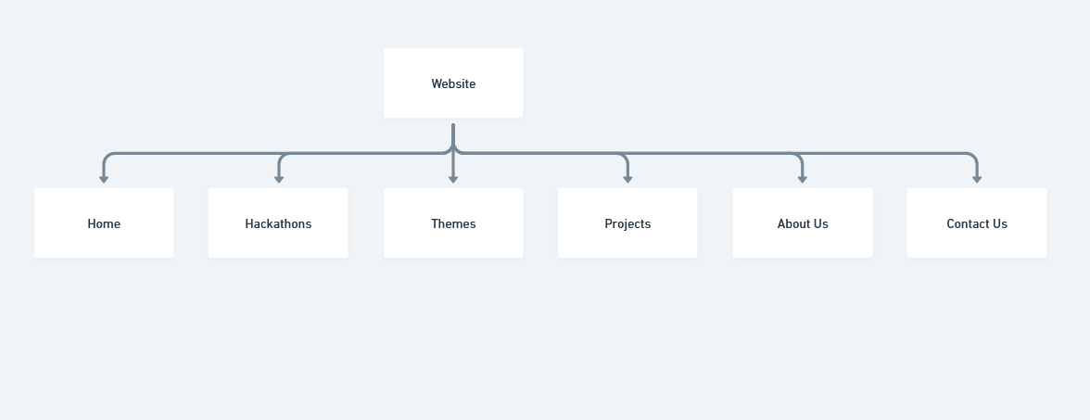

Home Page
The SparkForge home page is designed as a centralized educational hub, utilizing a clean, modular layout to guide users through the fundamentals of hackathons. The site’s structure and navigation are defined by the following components:
- Global Navigation Bar:
Located at the top of the page, the header provides persistent access to primary site sections, including "Hackathon," "Themes," "Projects," and "About Us". A prominent "Contact Us" call-to-action (CTA) button is positioned in the top-right corner to facilitate direct user engagement.
- Hero Section:
The top of the page features a high-impact hero banner titled "Hackathons: A Beginner's Guide". It includes a brief value proposition and a primary "Explore Hackathon" button designed to funnel users deeper into the site’s core content.
- Modular Content Grid:
The main body of the site is organized into distinct, easy-to-read sections that address key user questions. This includes detailed modules for "What Are Hackathons?", "Why Hackathons Exist," and "Benefits of Participating," which uses a horizontal card layout to highlight specific growth areas like technical skills and networking.
- Informational Hierarchy:
The page continues with structured sections regarding participation logistics, such as "Online vs On-site Hackathons," "Who Can Participate?", and "Skills Gained". A "Common Misconceptions" section uses a card-based design to debunk frequent myths, improving user clarity.
- Footer and Platform Identity:
The bottom of the site contains an "About This Platform" summary, clarifying the site’s mission as an educational resource rather than a registration portal. The footer reinforces the brand identity with the tagline, "© 2026 SparkForge. Built for innovators".

Hackathons

The Hackathon details page utilizes a structured, single-column vertical scroll to present logistical information and event-specific details. Its navigation and layout include:
- Integrated Header Navigation:
The page maintains the global navigation bar with links to "Hackathon," "Themes," "Projects," and "About Us," ensuring consistent user orientation across the platform.
- Action-Oriented Hero Banner:
The top of the page features a prominent title, "Upcoming Hackathon — Schedule & Details," accompanied by dual Call-to-Action (CTA) buttons: "See Schedule" and "Register".
- Categorized Information Modules:
Content is organized into distinct, high-contrast sections to improve readability. Key modules include:
Schedule (Example):
Provides a day-by-day breakdown of the event timeline from "Day 0" to "Day 3".
  - Participation Requirements:
Clearly outlines "Who Can Participate," team size recommendations, and registration requirements.
  - Suggested Topics & Tracks:
Uses a multi-card grid layout to categorize themes like "Machine Learning / AI," "Health & Wellbeing," and "Climate & Sustainability".
  - Evaluation and Incentives:
Dedicated sections for "Judging Criteria" and "Prizes" (listed in PKR) provide transparency on how participants are assessed and rewarded.
- Internal Linking and Resources:
The page includes CTA buttons for "Reference Projects" and "Theme Information," directing users to supplementary pages for inspiration and deeper insights.
- Contact and Registration Guidance:
The final section provides "Registration & Tips," pointing users toward the "Contact Us" page or signup links to complete their entry.
The "Top Hackathon Themes" page is a data-focused reference tool designed for quick comparison of industry trends. Its navigation and layout include:

Themes
- Global Navigation:
Features the standard header with links to "Hackathon," "Themes," "Projects," and "About Us," plus a "Contact Us" CTA.
- Ranked Data Table:
Centered on a "Top Hackathon Themes" table that categorizes 14 diverse tracks.
- Key Metrics:
- The layout uses a four-column grid to display theme rank, title, frequency of hackathons, and total prize pools.
Consistent Footer:
- Ends with the "SparkForge 2026" branding to maintain site-wide visual continuity.

Projects
The Projects page is designed as a static gallery to provide inspiration through past examples. Its navigation and layout include:
- Standardized Header:
Maintains site-wide navigation links to "Hackathon," "Themes," "Projects," and "About Us," with a "Contact Us" button.
- Hero Section:
Features a high-impact banner titled "Projects — 2025 Highlights (Reference)" with a brief disclaimer that the content is for inspiration only.
- Grid-Based Showcase:
Organized into a "2025 Featured Projects" section using a multi-column card layout.
- Project Cards:
Each card displays a representative image, project title, descriptive summary, and technical tags (e.g., "Climate," "ML," "FinTech").
- Informational Footer:
Includes a "Notes" section explaining the non-interactive nature of the cards, followed by the "SparkForge 2026" brand footer.

About Us
The "About Us" page focuses on platform transparency and team roles through a clean, card-based layout. Its navigation and structure include:
- Global Navigation Bar:
Features standard links to "Hackathon," "Themes," and "Projects," with a persistent "Contact Us" call-to-action.
- "Our Team" Grid:
The main body is organized into a modular grid showcasing key operational roles.
- Role-Based Cards:
Each card uses a minimalist design including initials, job titles (such as Engineering Lead and Content Specialist), and brief summaries of how each role supports the platform's educational mission.
- Consistent Visual Identity:
Maintains the site’s professional green and orange color palette to ensure a cohesive user experience across all sub-pages.

Contact Us page
The Contact page is a minimalist, single-purpose interface designed for direct user communication. Its layout and navigation include:
- Persistent Navigation Header:
Retains standard links to the primary sections ("Hackathon," "Themes," "Projects") and an "About Us" link.
- Dual Communication Channels:
Provides a direct email address for general feedback and a structured web form for specific inquiries.
- Structured Input Form:
Features a clean, card-style container with dedicated fields for "Your name," "Email," "Subject," and a multi-line "Message" area.
- Actionable Form Controls:
Includes high-contrast "Send Message" and "Cancel" buttons at the bottom of the form for clear user intent.
- Standardized Footer:
Consistent with the rest of the site, it features the "2026 SparkForge" copyright and mission statement.

Assets Used (Design and Color choices)
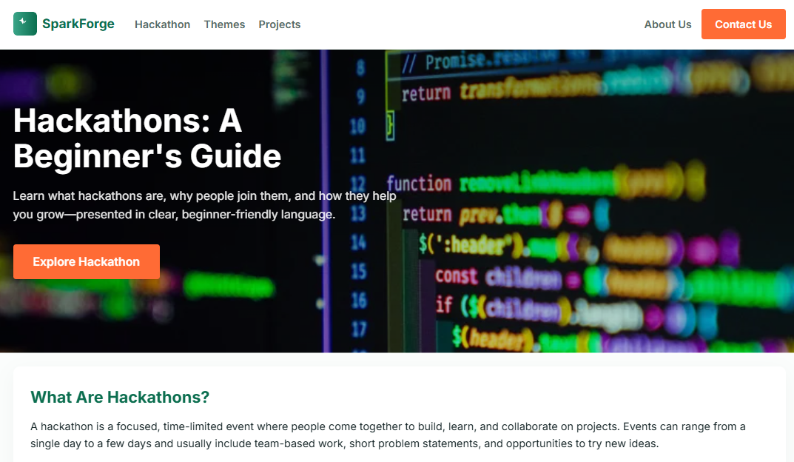
The SparkForge platform utilizes a mix of visual assets and structured data to enhance the educational experience for users. Below is a breakdown of the assets used across the site:
- Dynamic Visual Imagery:
  - Hero Banners:
High-resolution, blurred code backgrounds are used on the Home, Hackathon, and Projects pages to establish a technical and innovative atmosphere.
  - Project Showcase Images:
The "Projects" page incorporates diverse, representative thumbnails for featured projects like "EcoAI," "HealHub," and "StudyBuddy" to provide visual context for past innovations.
  - Team Identifiers:
The "About Us" page uses circular, color-coded letter avatars (e.g., "SA," "MB," "TJ") to represent team members in a clean, minimalist style.
- Data and Information Sources:
  - Thematic Rankings:
A comprehensive dataset is utilized for the "Top Hackathon Themes" table, tracking 14 different categories alongside frequency metrics and prize pool totals.
  - Curated Content:
Informational modules on the home page, such as "Common Misconceptions" and "Benefits of Participating," are based on general industry standards for hackathon education.
  - Event Logistics:
The "Upcoming Hackathon" page uses structured schedule data (e.g., Day 0 to Day 3) and specific prize distributions in PKR (Pakistani Rupee) to provide realistic event simulations.
- Branding Assets:
  - Platform Identity:
A consistent SVG-style "SparkForge" logo featuring a green flame icon is present in the header of every page.
  - Call-to-Action (CTA) UI:
Standardized orange and green buttons (e.g., "Explore Hackathon," "Register," "Send Message") are used throughout the site to maintain interactive consistency.

How to Run the Site

Website can be opened using this link
SparkForge

Reflection
The development of the SparkForge platform provided significant insights into creating accessible educational resources for the tech community.

Key Learnings
- Information Hierarchy:
We learned that presenting dense technical information, such as hackathon schedules or judging criteria, requires a clear modular layout to prevent user fatigue.
- Data Visualization:
Implementing a structured table for the "Top Hackathon Themes" highlighted the importance of using quantifiable data (like prize pools and frequency) to build platform credibility.
- Persona-Based Design:
By structuring the home page around beginner-specific questions ("What Are Hackathons?"), we learned how to tailor a user experience for a specific non-expert audience.
- Visual Consistency:
Maintaining a uniform color palette (green and orange) and header/footer across all six pages reinforced the brand identity and improved site-wide navigation.

Planned Improvements
- Interactive Project Gallery:
While the current project cards are for reference only, future iterations could include clickable links to GitHub repositories or live demos.
- Real-Time Registration:
The "Upcoming Hackathon" page currently uses a static schedule; integrating a live database for real-time registration and team formation would be a logical next step.
- Thematic Search and Filtering:
Adding a search function to the "Themes" table would help users quickly find specific tracks as the dataset grows beyond 14 categories.
- Dynamic Contact Feedback:
Implementing a "Success" message or automated response upon submitting the contact form would enhance the user communication experience.

